*LAB # 07*

*OPEN-ENDED*

*Take your Roll no. and Date of birth (day only in integer) as input and subtract them*

**CODE:**

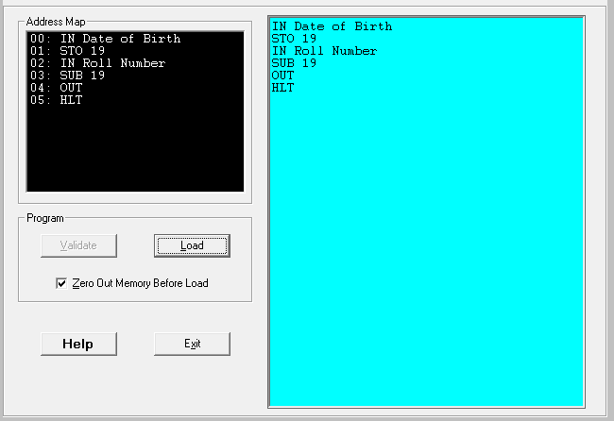

**OUTPUT (Hardware View):**

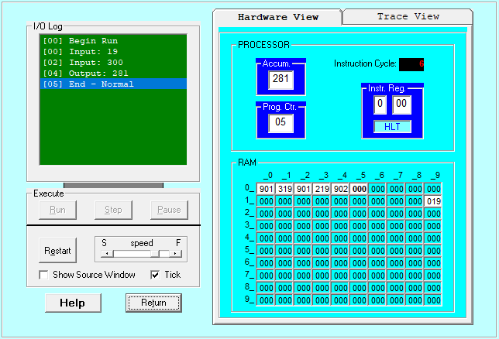

**OUTPUT (Trace View):**

